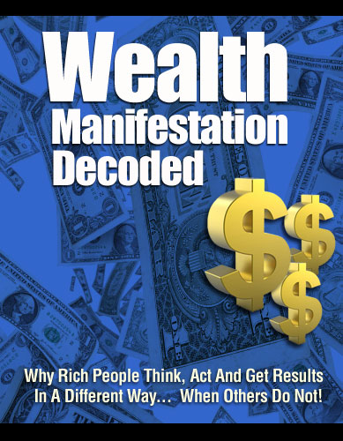

LIMITS OF LIABILITY / DISCLAIMER OF WARRANTY:
The Authors has strived to be as accurate and complete as possible in the creation of this manual, notwithstanding the fact that he does not warrant or represent at any time that the contents within are accurate due to the rapidly changing nature of the Internet.

While all attempts have been made to verify information provided in this publication, the Authors assume no responsibility for errors, omissions, or contrary interpretation of the subject matter herein. Any perceived slights of specific persons, peoples, or organizations are unintentional.

There are no guarantees of income made. Readers are cautioned to reply on their own judgment about their individual circumstances to act accordingly. This book is not intended for use as a source of legal, business, accounting or financial advice. All readers are advised to seek services of competent professionals in legal, business, accounting, and finance field.

Screen shots seen in this manual are from publicly accessible files and web pages and used as “fair use” for reporting purposes and to illustrate various points mentioned herein. Texts and images available over the Internet may be subject to copyright and other intellectual rights owned by third parties.

10 Distinct Differences of Rich People from Poor People
Many people think that life is very unfair. Here you are working hard and yet your income is not even enough to buy you an ice cream. On the other side of the coin, you know someone who does not even shed a drop of sweat and yet lies in luxury. If you think that life has been so rude on you and you were only born to suffer your destiny, then you are thinking as a poor man would think. But if you think that you are the master of your destiny and you are in total control of your life, then you have a rich man’s mentality.
Knowing the well-kept secrets of millionaires is the key to unlock the door of success. In most cases, wealthy people will tell you that there is no exact formula to become well off in life. The secret lies in the attitude that facilitates the flow of wealth. The approach is about the psychological aspect of the rich people.
In our present society, the gap between the rich and the poor is growing wider everyday. The rich becomes richer while the poor becomes poorer. To help us understand the satirical situation, we need to go into the mentality of the rich and blessed people and compare it with the way of thinking of the poor and underprivileged people. Here are the ten distinct differences in the money mentality of the rich versus the poor people. While reading the differences, try to assess your own mindset and see where yours mostly belong.
But remember that by defining ‘rich’ and ‘poor’ I am not referring to an individual’s current bank account size, net worth, assets, and so on. But rather, I am referring to the state of mind. A human mind is so powerful it can create assets, or even liabilities. If you have a mind conditioned to be poor, no matter what wealth you have today you can lose it all sooner or later. On the other hand, if you have the mind of a rich person’s, you can create your wealth from scratch or get it all back faster than it took you the first time, even if you lose it all today.
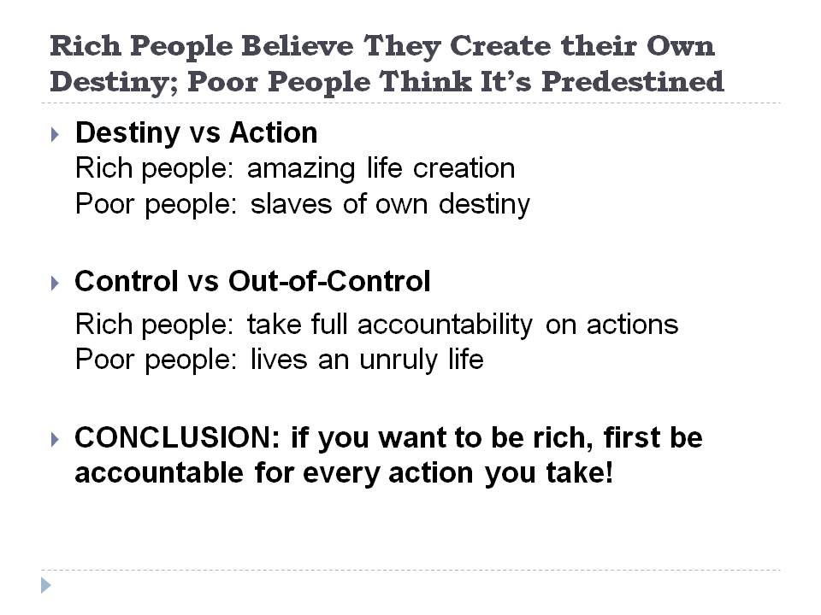
- Rich People Believe that They Create their Own Destiny while Poor People Believe that they are Predestined
Destiny refers to the predetermined course of events in one’s life. The idea of destiny has a deep history and divine intervention is the most popular belief. People trust that their lives depend on the will of a supernatural being. All of the actions are in vain if it does not coincide with the will of the divine.
- Destiny versus Action
Rich People
Rich people create an amazing life because they do not believe in predetermined fate. Instead, they believe that life is what they make it. If you repose all day and wait for the big fruit to fall into your mouth, nothing will move. Everything will stay in its place unless you move it. Like Newton’s Law of Motion, “Unless acted upon by a net external force, a body at rest remains at rest and a body in motion remains in motion”. This scientific example is true even in real life and rich people apply this theory in their lives. For rich people, they believe they are responsible for their own life. They create their own destiny and not the economy, luck or knowledge.
Poor People
Poor people, on the other hand, believe that they are the slaves of their own destiny. Whatever they do, adversaries come no matter how they elude them.
- In-Control versus Out-of-Control
Poor People
Poor people believe they live an unruly life. Their existence is very uncontrollable. When they act, the results are always unmanageable. When they fail in their endeavors, they blame the economy, the boss, their family and others who did not go accordingly.
Rich People
Rich people think otherwise. Life is a series of plans. With the right planning and appropriate actions, the results are favorable. They take full accountability for all their actions.
Conclusion:
When you keep on thinking that life only happens to you, you will eventually lose the power to change things and control your life. A rich man takes responsibility for the circumstances he created while a poor man feels like a victim of the world. If you want to attain financial abundance, think as a rich man would do. Believe that you create your future and not other people or events.
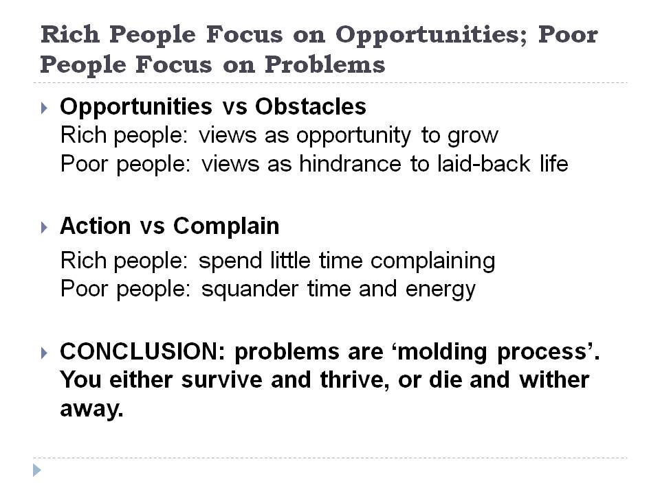
- Rich people focus on opportunities while poor people focus on problems
Opportunities come in both direct and indirect ways. Problems mask the chances that come. When you look at things superficially, you only see the façade and fail to appreciate the blessing under.
- Opportunities versus Obstacles
Poor People
The difference between rich people and poor people is the attitude towards a problem. When faced with a problem, a poor man sees it as an obstacle to his easy life. He detests difficulties and sees it as a hindrance to his laid-back life. The more problems he faces, the more he views his life as complicated.

Rich People
Rich people see problem as a door for new opportunities. They focus on solution rather than dawdle in despair. With every obstacle, they treat things positively and look beyond what is obvious. Rich people concentrate in finding solutions to their crisis. They elucidate things to see things at a better perspective.
- Action versus Complain
Poor People
Poor people keep on complaining about the obstacles. They squander time whining about the circumstances in their life. At the end of the day, their grumble intensifies since they have not done anything to solve the issue.
Rich People
Rich people act on their problems. They may moan a little, but they work to unravel the misery. The more problems they solve, the better their feeling.
Conclusion
Problems and failures are part of your molding process to become tough and be a better person. With problems, you learn from your mistakes and do better when the next one comes. When you face an opportunity, you come up with creative solutions. Avoid the poor man’s action of sitting down and staying cranky about it.
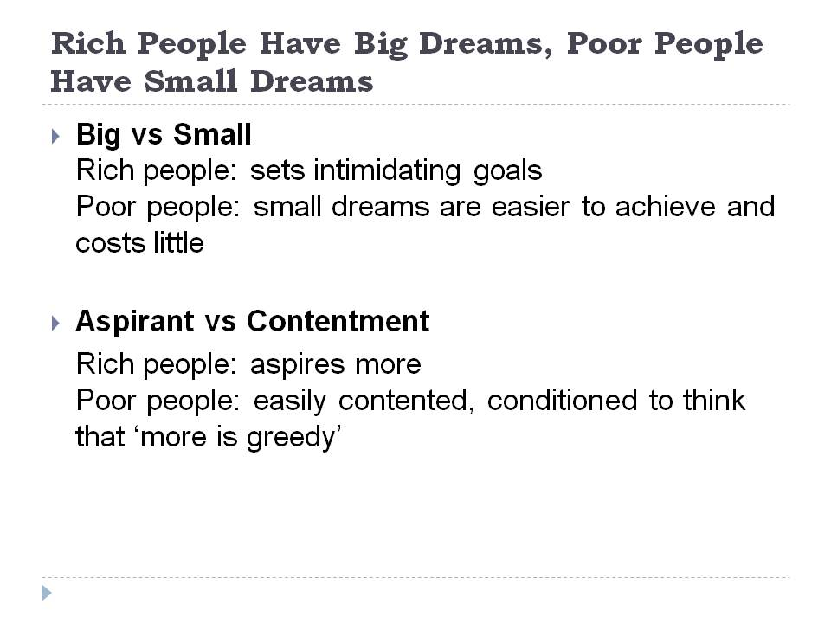
- Rich people have big dreams while poor people dream small.
Dreaming is the motivation to success. When a person dreams, he exerts effort to attain his dreams. Both rich and poor people dream. The difference is the size of their dream. When you have small dreams, you work less whereas big dreamers work harder to achieve their vision.
- Big versus Small
Poor People
Poor people have little dreams. They often dream to eat three times a day, have a small house to live in and get a job with good pay. These are all the dreams of a poor man. Because any casual employee can easily achieve these, many poor people feel they do not need to exert any more effort. Anyway, why work harder? They have achieved their dream after all.

Rich People
For rich people, to achieve big things, you have to dream big. Wealthy men stick to this principle. They do not dream to eat three times a day, they dream to eat more than that in luxury. They do not dream of a small house, they dream of a comfortable house for their family plus a rest house during their vacations. They do not dream for job with good pay. Instead, they create jobs.

- Aspirant versus Contentment
Poor People
Poor people get contented with what they have. They do not aspire for more. They believe that to desire for more things means to complicate your life. When poor people achieve their small dreams, they start to live a shoddy life.

Rich People
Rich people aspire for more. They believe that their abilities can bring them to places. Because they have big dreams, they work hard to turn aspirations to reality.

Conclusion
You cannot achieve bigger things if you only have small dreams. When you dream, dream big, anyway, there is nothing to lose in dreaming.
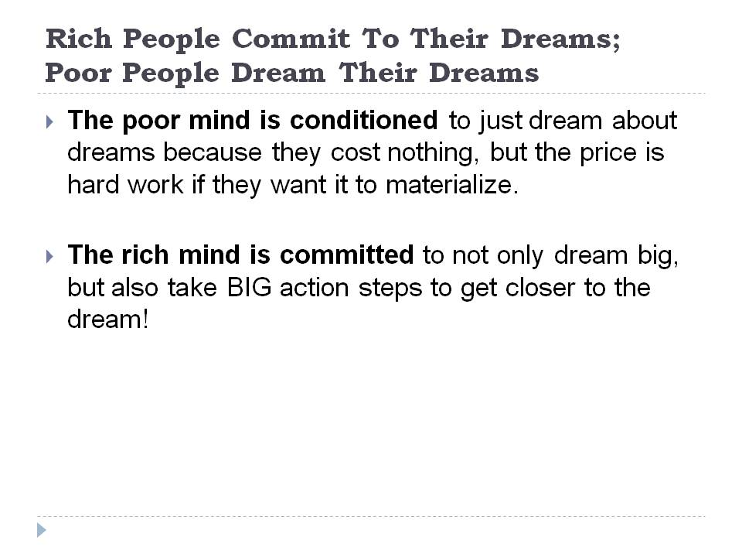
- Rich people commit to their dreams while poor people sleep dreaming their dreams
It is a fact that dreams is the initial step to success. But it does not end there. In order for dreams to come true, you have to work for them.
- Commitment versus Dreaming
Poor People
Poor people love to dream even when the sun is all up. They stay in dreamy mood even when it is time to work. They keep on dreaming that things will just happen in a snap. They keep on thinking how good it is to live in opulence but never do anything to experience it.

Rich People
Rich people work hard on their dreams. They commit each day of their lives to reach their goals. They pile up their efforts to assemble their dream life.
Conclusion
Dreaming big does not make you rich. You need to work hard when you set your goals. Small steps every day are better than just waiting for time to pass without action. At the end of the day, the small deeds can accumulate and lead you to the stairs of success.
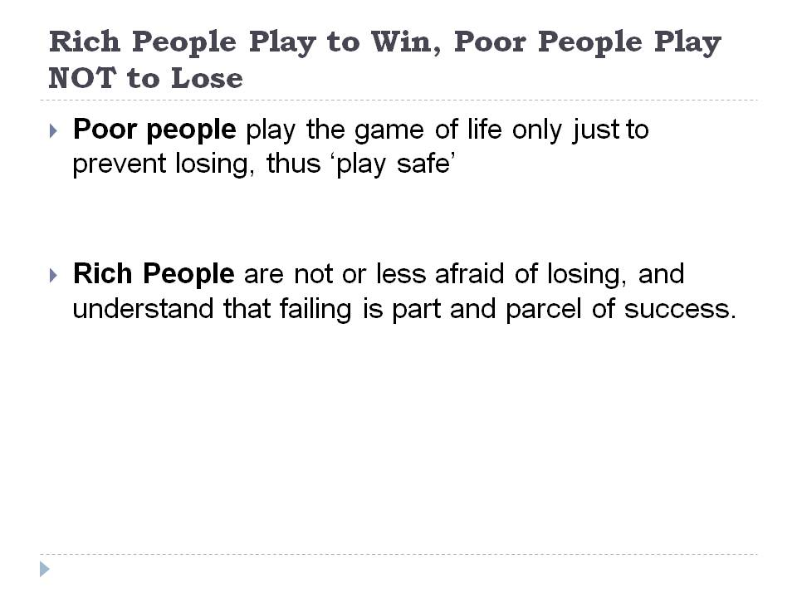
- Rich people play to win while poor people play only not to lose money
The big mindset difference is the purpose of playing the game. Life is a gamble. Every decision is a risk. There are no certain in this world.
- Risk-taker versus Playing Safe
Poor People
Poor people play the game of life only just to prevent losing. They are too careful to invest and make sure that things turn out the way they want. When in doubt, they never make decision. They always stay on the safe side. They stay attached to the stigma of failure and too afraid of making mistakes.
Rich People
For rich people, life is about taking risk. Because they exactly know what they want, they invest in order to win. For them losing is never an option, they study and analyze how things work and invest once they get to know the flow of things.
Conclusion
Only those who are willing to take risk achieve financial stability and abundance. The bigger the risk that you take, the bigger is your reward. However, even rich people do not jump to risks without preparation. When you are to take a risk, be sure that your preparation is enough to ensure winning. Be armed when you gamble with life.
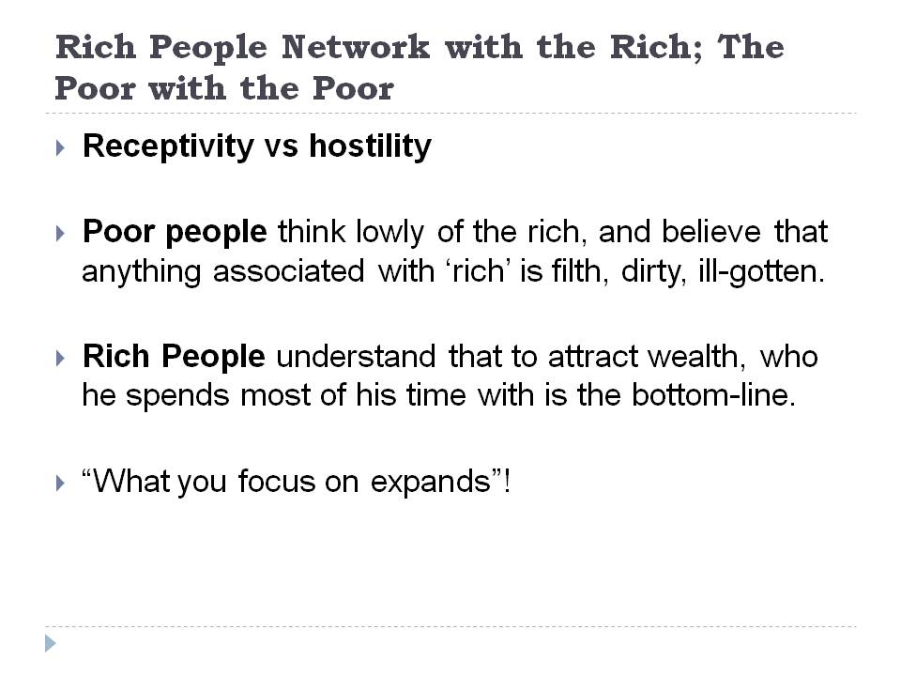
- Rich people network with the rich and successful people while the poor people network with poor people.
The people around you have an indirect effect on our ways of thinking. Try to associate with pessimist people and you will be a pessimist eventually. However, when you go to a company of jovial individuals, you absorb their cheerfulness.
- Receptivity versus hostility
Poor people
Poor people are hostile to rich people. They think that their lifestyle is not tolerable. Instead, they associate with people with the same income as theirs. They spend time wondering how rich people become richer and envy the luck they have.

Rich People
Rich people are receptive to new ideas and new people. They spend time with people who can help them achieve their dreams. They join people earning six digits or more. They analyze how these wealthy people become richer and imbibe their ways and thinking.
Conclusion
Poor people think that your wealth depends on your family origin. You are rich if only you belong to a family of rich. Rich people think otherwise. They go with people who can help them. They talk to financially successful people taking notes of their secrets to prosperity. With the right associations, you can become rich even when you come from poor family.
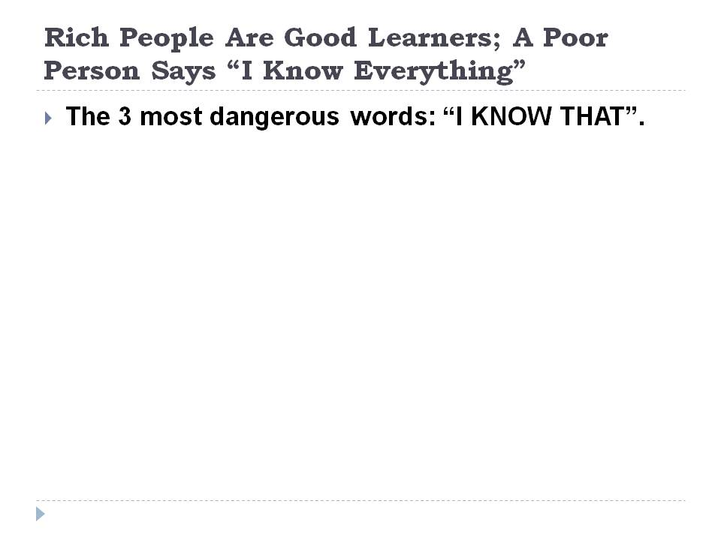
- Rich people are good learners while poor people think they know everything.
Life is about learning. When you declare that, you know everything, learning stops. However, when you admit you still need more knowledge, you will yearn to learn more.
- Open-mindedness versus Close-mindedness
Poor People
Poor people believe that they know everything. They know how life works and how to live well. Their beliefs make them close their minds to new ideas. If you are not willing to learn, you will never know why rich people become richer and why remain poor despite all your efforts.

Rich People
Rich people admit that they still need to learn. When you give a room for improvement and new ideas, you open your mind to possibilities. One of the easiest ways to financial abundance is to learn from people who achieved the status.
Conclusion:
The key to financial success is to accept your shortcomings and learn from people. To be the best, you need to learn from the best and learn to be the best. Only when you open up for learning can you live a life of abundance.
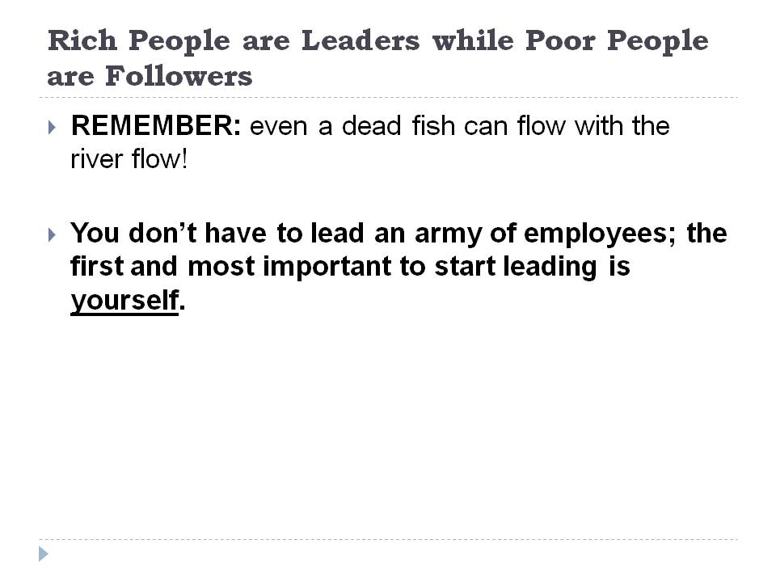
- Rich People are Leaders while People are Followers
Most financially successful people lead the way. Being a leader, you are in front of the actions. Because of the courage needed to be a leader, only those with strong personality become the manager.
- Leaders versus Followers
Poor People
Poor people have herd mentality. They like to follow where the water flows. Instead of taking the lead, they are happy to let others do the thinking. They do not want to take responsibility over their decisions. When somebody asks for their opinion, they pass it to others so as not to take the blame for failures later on.

Rich People
Rich people take the initiative. They decide for themselves and take full responsibility for their decisions. They can work independently.
Conclusion
Rich people are leaders and leaders are rich people. This idea comes because of the independent attitude of leaders and rich people. Even if an ordinary office setting, the leaders are often responsible for the whole group. They may have bigger responsibilities but they get higher pays too.
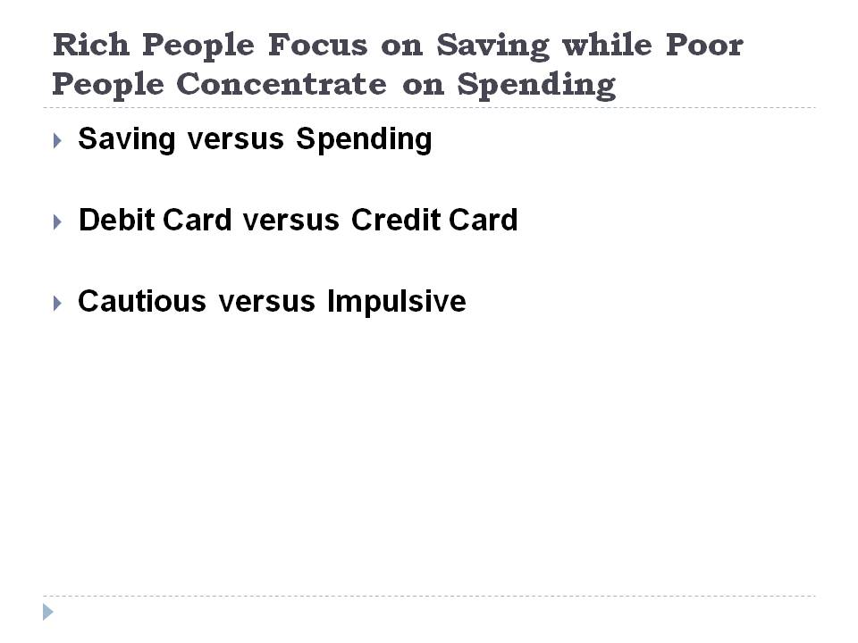
- Rich people focus on saving while poor people concentrate on spending
No matter how small or big your earning is, saving is a crucial part of becoming rich. If you try to save even ten dollars a day, that means 3,650 dollars a year and 36, 500 in ten years. Well that is even less the interest you get from the bank. Even if you earn 100,000 dollars a month but you also spend the whole amount, you will never get rich until your death.
- Saving versus Spending
Poor People
Poor people usually spend more than what they earn. They do not believe in the value of savings. They earn 100 dollars and spend 110 dollars. In time, the excess expenditure piles up and before they know it, they are drowning in debt.
Rich People
Rich people stays on a monthly and even daily budget. They spend only within their declared budget. They save a portion of their earning in the bank to earn further interest.
- Debit Card versus Credit Card
Poor People
Poor people rely on credit cards. They cannot live without them. They dine out, shop and indulge to vacations using their plastic cards. Because they do not see the expenses and their cash remains intact, they feel that they are in complete control of their finances. Only to find out later on that everything is getting out of control.
Rich People
Rich people do not purchase with credit cards. If they do not have cash, they use debit cards. They believe in the saying, “if you cannot afford it cash, you really cannot afford it”.

- Cautious versus Impulsive
Poor People
Poor people are impulsive buyers. They buy anything on sale and anything discounted. Even if they do not need the items, they keep on buying thinking that they can save from the discounts.
Rich People
Rich people think about the product many times before purchasing. They consider the affordability, quality and the usefulness of the item. When the item fails one of the criteria, they think about it repeatedly before finally deciding.
Conclusion

Earning money is hard. Because of the difficulty earning it, think twice or even thrice before you let go of your hard-earned income. No one knows the future, it is therefore important to save to ensure that you have something in case of drought.

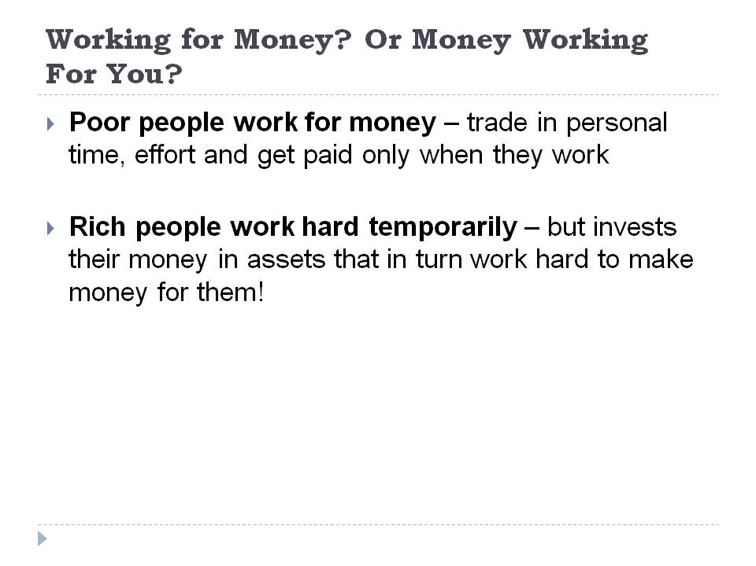

- Rich people have their money work hard for them while poor people work hard for their money.

Everybody works hard. The way to let your money work for you is to know where to invest it. If you know where to put your investments, then you will make your money work hard for you.

- Successful Investment versus Futile Investment

Poor People

Poor people keep on looking for money to come along. They keep on working and working to earn. They spend beyond their means and resort to loans that accumulate interest.

Rich People

Rich people know where to invest their money. Instead of the banks charging them for credit card interest, they collect the interest of their savings. They experience a restful life while their money is working for them.

Conclusion

In order to stop working hard for your money as poor people do, live within your means and save up. Let your money do the work and enjoy life.

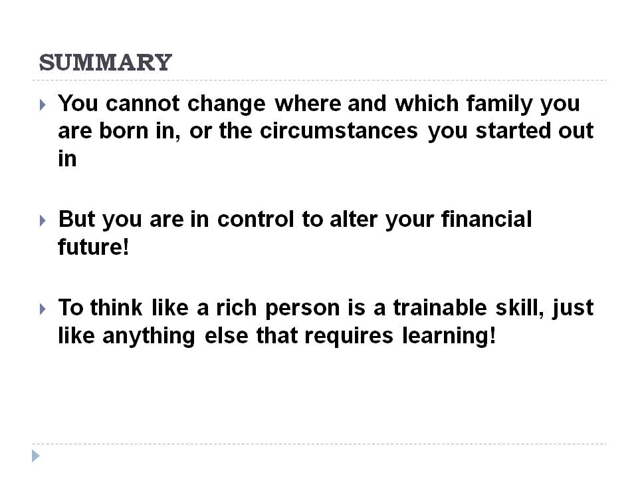

Summary
You cannot blame anyone born in a poor family. Maybe you can call that destiny. But to die still as poor as the rats, you blame only yourself. At an average, a man lives for 70 years. The approximately 25,550 days of your life is enough to make you rich. If you waste your days, destiny should not be the reason why you remained poor for the rest of your life.
The secret of millionaires is easy. They take each day as a new beginning to face the challenges that will help them achieve their big dreams. Complaining is a total waste of time. Instead of comparing yourself with others, they work on their own lives. They take initiative rather than mere following. They are confident of their knowledge and skills and do not fear to take the risk.
Despite the destitute situation around us, money is in abundance. You can see money everywhere. It is just at the wrong place at the wrong time. To take advantage of the prosperity, be at the right place at the right time. Act. Find the opportunities to become rich.
Where can you classify yourself? Do you possess the mentality to become rich or negativities dominate your mind? Getting rich is very simple. All you need is the right attitude, mentality and action. With these characteristics, embarking the long and winding road to wealth is only a step away. Adapt the mentality of the rich and be rich; and otherwise, stay poor with the habits and mindset of the poor.

The 4 Essential Wealth Skills

It is probably silly to ask people who wants to be a millionaire. Without the need for further studies and researches, the answer will be a resounding yes. Earning beyond what you need and spending on the things that you do not only need but also the things that you want are luxurious dreams of many. It is everyone’s dream to trot around the world, send the children in esteemed universities, indulge in lavish pampering and donate to charities to help the poor. To take pleasure in all of these seems to be a distant ambition.

Everyone wants to be a millionaire. But the key to being one of the richest men in the world is to know the essentials to bring all the luck you need. Although there is no exact formula for richness, there are keys that will help you unlock the doors to success. It boils down to an effective system that rich and wealthy people apply. This should probably be very effective for them to live in luxury and their children’s grandchildren. To employ the same skills will lose you nothing. Anyway, yes, you eat three times a day but you barely fit in the trivial income your family has.

Before introducing the essential wealth skills, it is only proper to prepare you to your journey to prosperity. Like in any endeavor, you need to prepare and arm yourself with the anticipated needs. In trotting through the road of financial abundance, you have to organize yourself. Here are the important things that you must bring with you as you move through the road to success.

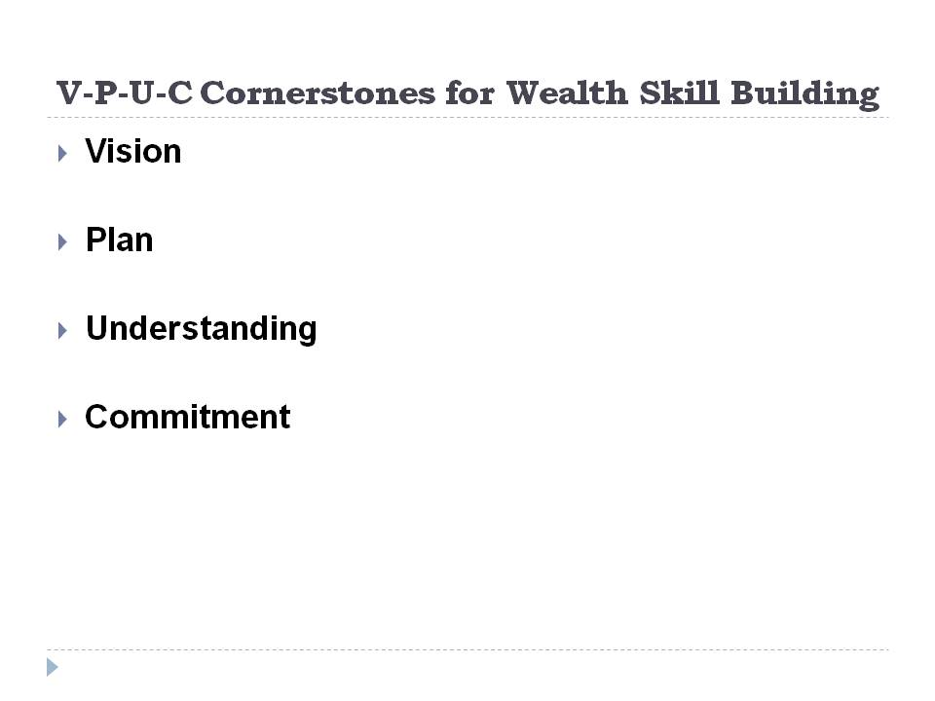

Vision

The start of financial abundance is the vision you have to set. As your vision gets bigger, your chance of becoming a millionaire is also bigger. Anyway, what is there that you have to lose? To count the countless millions in your hands, you need to visualize yourself with hands on your fortune. Do you want a car, two cars or three? Do you want to have one successful business or an international business with branches all over the world? Think and imagine what your power can accommodate. Focus on the positive outcome of things and envision a comfortable and financially abundant life for you and your family. If you believe this will happen, it will. Otherwise, your doubts will keep you stationary.

Plan
Wealthy people do not just dream. They plan things and they do it specifically. They have a plan everyday and they stick to it. They consider each day as a day to contribute to their future success. You just cannot leave your life to luck or as poor people see it, to destiny. Millionaires do not believe in predetermined fate. Instead, they hold responsible for their lives. They are in perfect control of their destiny. Instead of sitting down, they write all their goals and make a systematic wealth plan that they religiously follow.
Understanding
For you to reach your goal and set plans, you need to understand your whole situation. Look at your status at a wider perspective. Millionaires understand the flow of many in their hands. They know how much comes in and how much should they let go. Poor people only try to balance this flow. Sometimes they output is even higher than input. But for millionaires, their cash output is lower than their cash input. Therefore, they can save from their earnings.

Commitment
To become a millionaire, you have to be committed to your dreams. Earning millions need a lot of effort and commitment. Remember, the road to financial abundance is not very easy. There will be myriad of obstacles. If you have little commitment to your dream, you can quickly give up when you stumble.

Here are the essential things that you have to bring with you along the road to millions. If you are ready to take a major turn in your life, read on below to know the secrets of those sleeping in luxury. Be ready to assess your own life and take action to make a change. As you read the article, you will be surprised to know that all you need to have are four wealth skills and you are ready to commence the journey to prosperity. Now, let us see if you can reach the end of the road.

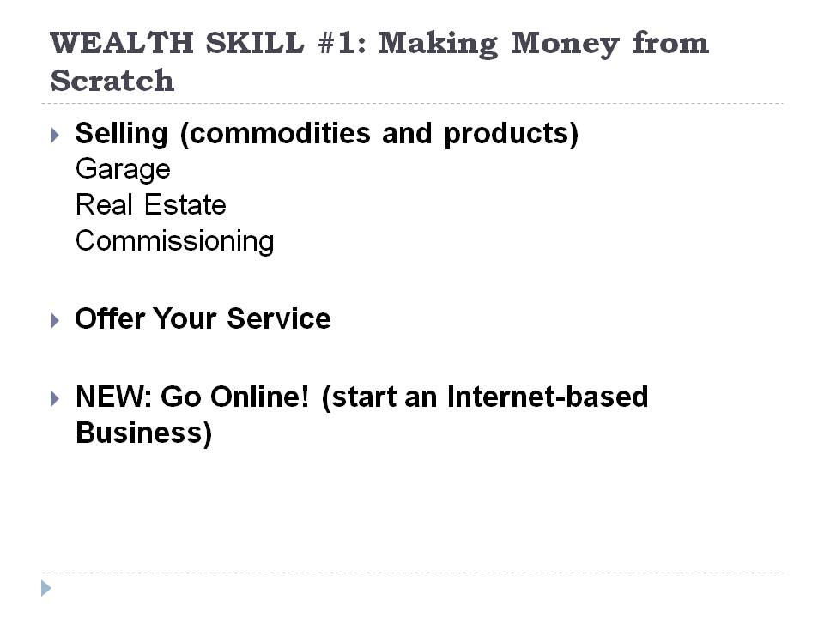
http://www.articlesbase.com/business-articles/five-core-steps-to-make-you-earn-your-millions-even-if-you-start-from-scratch-657424.html

WEALTH SKILL #1: Making Money from Scratch
It may be quite skeptical to become a millionaire from scratch. But it is true. Many rich men started from nothing.
Unlike other people who have a thick checkbook, plentiful savings and many properties to liquidate to start up a business, you are probably thinking that you can never be a candidate to become a millionaire. However, you do not need all these. All you need is yourself. You are the biggest and most indispensable asset of your future business. There are many known ways to make money from scratch. If you think this is impossible, then look around. Most successful people started out of scratch. All you need to do is to let your imagination work, be creative and confident.
- Selling
Garage Sale
Selling is the traditional way of making money from scratch. You can sell your stuffs especially your second hand things, junks or other odds. Instead of keeping the items in your storeroom, you can turn these into cash. When you do this, you will be one of those who will say, “There is money in trash.”
Real Estate
If you have a good communication skill, then, you have the power to convince people with your words and your words can be your best asset. Many successful real estate entrepreneurs started from scratch. With only their voice and words as starting capital, they were able to create millions.
Commissioning
Aside from real estate, you can also sell of other people’s products. You can offer selling their stuffs along with your own. In return, you can get commission for every item sold.

Selling gives you unlimited source of funds. As long as you are industrious in dealing with different people, it is a sure hit. However, since you work in a customer related environment, be sure to have a lot of patience. You will meet people with varied personalities that will test your character. But do not get into them. Keep in mind that they can be your potential key to success.
If you are into selling, you have to be always on the go. If your business calls for it, you need to be where the action is. Time flexibility is very crucial since many clients do not want waiting and there are many competitors out there yearning to earn as much as you do. Although it may seem to be a tough start up, you will gain the fruit of your efforts as you create a name for yourself. When that happens, you can be the boss of your own company.
- Offer your Service
Each person has a unique skill to offer. The secret to making money from scratch is by taking advantage of your uniqueness. You can stand out from the crowd when you show your exceptional ability, talent or skill. To turn your skill into cash, offer your service to others. Advertise yourself and keep your customers satisfied to ensure a repeat customer or referral from others. Aside from the usual forms of advertisements, do not forget to charm people. Millionaires have a certain charm that draws people to them. As you bring more people closer to your services, your very own company will be a multi-million worth in no time.
Offering services is not only easy money. It also serves as an outlet for your talents, skills and abilities. Remember, you were not here to keep your uniqueness within. You have to share it to the world and make it known. It does not only improve you, it also benefits other people.
The whole idea is to look for problems of clients and find solution to those problems. If people worry about broken things, fix them. As long as you find a solution for their most common problems and needs, then you will never lose your business market.
- Go Online!
With the advent of online businesses, you do not need to go out of your own comforts just to get a six-figure income. You can earn money right form your home as long as you have internet access. When you are online, the possibilities of making money from scratch are endless. Money is just under your nose and only one click away. The good thing with online job is you get to stay at home, with no bosses and still you earn better than those working within the bounds of their office. Here are the common online money making jobs.
Online Blogging
Online blogging started out as a hobby of people. It was their outlet on their emotions and everyday sentiments. However, as people relate to your own stories, you acquire followers that contribute to your blogs. As your blogs increase in number, visitors come and interact with you. When online advertisers see the increase in traffic in your site, they begin to ask for an ad space, and this can be your chance to earn income from something that started out as a hobby.
Article Writing
People use the internet as their primary source of information. This is the reason why online marketers require huge amount of information to satisfy the majority of online searchers. However, not all people have the time and talent to write and this is where you can come in. You can write for somebody and get payment for it.
Making money from scratch is tough. Your capital is only yourself. However, do not worry; you have the best starting capital that even big companies do not have. In investing huge amount of money, you also risk a lot. However when you start from scratch, you have nothing to lose and everything to gain. It may be quite challenging but the rewards are gratifying. If you want your first million now, you can have it right away. It is your own pace and no one will dictate how much or how little you can earn.
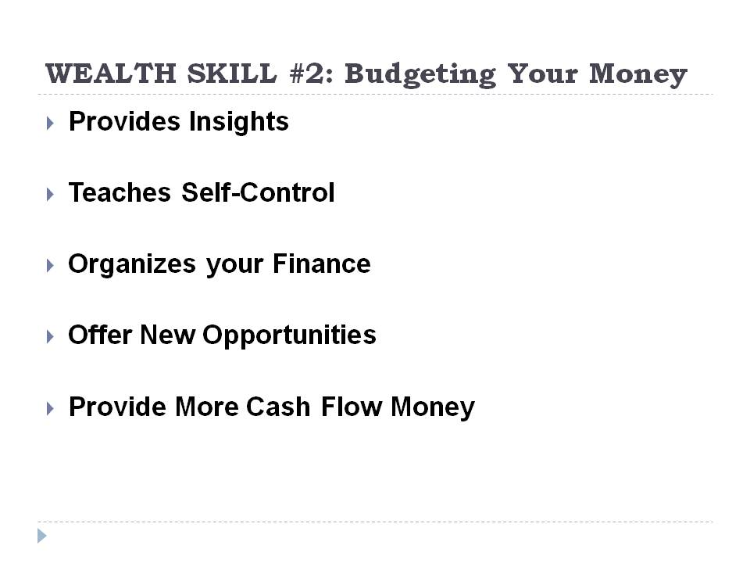

WEALTH SKILL #2: Budgeting Your Money

In the first part of the article, it mentioned about understanding your money. If you want to be a millionaire, you need to learn the wealth skill number two, budgeting your money. Rich people do not spend more than what they earn. Instead, they religiously keep a portion of it and let it earn interest. To follow their footsteps, you learn to manage your finances. Unless you learn this important skill, you will never reach the road to financial abundance.

Importance of Budgeting your Money

Provides Insights

Budgeting your money gives you knowledge of your earnings and spending. When you a basic knowledge of the whereabouts of your money, you create financial stability which is the crucial step to abundance.

Teaches Self-Control
When you know how to budget your money, you develop self-discipline. You are able to control your finances and avoid unnecessary expenses. Learning to budget makes you the boss of your money instead of being a slave to your finances.
Organizes your Finance
Organizing your finances warns you for any potential financial problem. Your budget can serve as a record of all your financial transactions, guide for paying utility bills and immediately warns you when you overspend.
Offer New Opportunities
When you know how to budget your money, you can grab opportunities that you may otherwise miss. Because you know the flow of money, you can exactly determine if you have excess funds to invest to other moneymaking opportunities.
Provide More Cash Flow Money
The greatest benefit of budgeting your money is having extra money. When you cut unnecessary payments like penalties and late interests, you can save up for your future needs. When you pay your bills on time, you not only avoid late charges but also create a good name for yourself and your company.
Earning your first million is challenging and budgeting it according to your needs is more challenging. The key to being rich is to be in control of your finances.
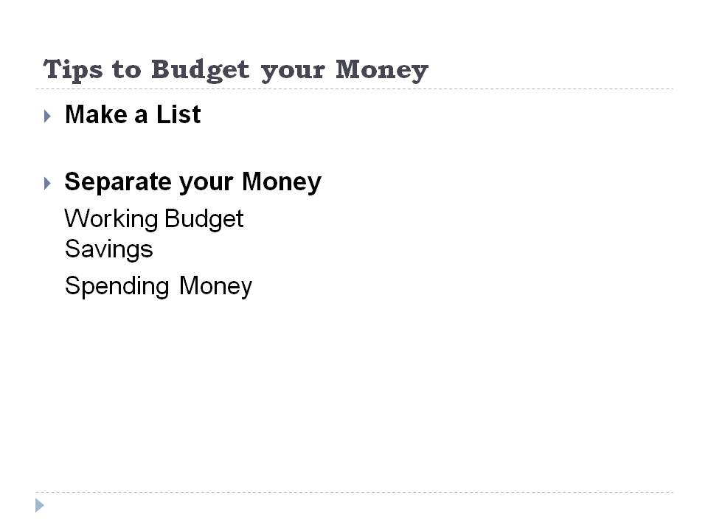
Knowing the benefits of budgeting is futile if you do not practice it. To arm you with the competence needed in Wealth skill number 2, here are the tips to help you stay within the budget.

Tips to Budget your Money

Make a List

When you receive your first million, keep it a habit to make a list of the things that you need to pay. Determine your future expenses and set aside funds for your needs. If you run a business, make sure you separate the working budget of your company. These include money for purchasing, maintenance and salary of your employees. If you do not have a company and only works for yourself or for others, know your expenditures until the next payday comes. Write specifically each item and opposite each, its corresponding amount. This way, you will know whether you are still within your budget or you are exceeding from your earnings.

Separate your Money

For people who are very impulsive when it comes to spending, separating the budget into parts is ideal. You can allocate your funds based on the following:

- Working Budget

Your working budget includes your daily or monthly expenses. Usually, this comprises the biggest share in the budget. This is where you will get the payment for your monthly bills, food, allowance and transportation.

- Savings

No matter how small your income, savings should be a part of your budget. To be wealthy means to save more than what you spend. Even a meager earner can become rich as long as you save enough for your future. The savings must comprise at least 20% to 30% of your monthly budget.

- Spending Money

Of course, life will be boring if you only work to live and save. Your monthly leisure activities must be a part of your budget. As the cliché goes, “All work with no play, makes a boy a dull one.” Working is more rewarding and fun if you get to treat yourself occasionally. You can get the money for your new clothes, vacation or pampering yourself from the spending money. To avoid overspending, make sure to leave your debit and credit cards at home and stay strictly within your spending money.

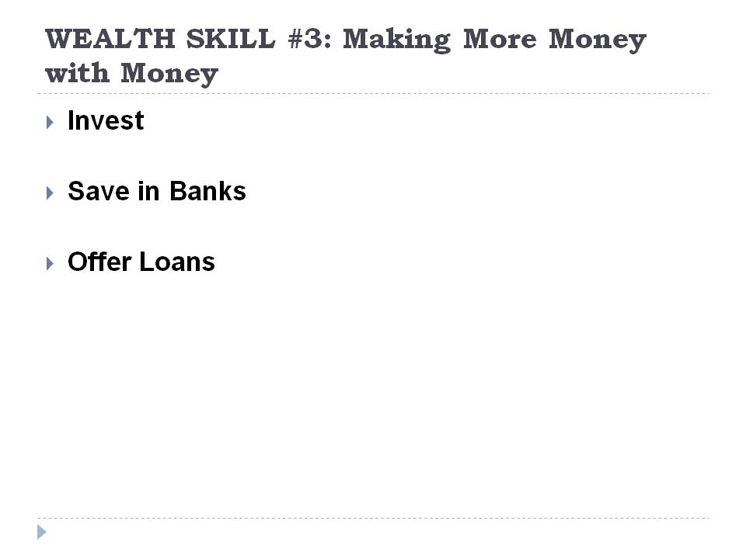

WEALTH SKILL #3: Making More Money with Money

Once you have your millions, you can become richer by comfortably sitting at home and letting your money do the work. Millionaires are richer not because they work hard to earn their millions but because they let their money work hard for them. If you are on the way to financial abundance, here are the proven ways to let your money do the work for you.

Invest

Investing is the wisest way to make your money work. However, wise investment is important for you to keep your money working. Before you invest, make sure you have the knowledge of the field where you want to invest. Invest in properties that appreciate in time like real estate properties and stocks. Do not invest in appliances, electronics or even automobiles. These things depreciate through time. This means instead of making more money out of your money, you end up with less.

Save in Banks

If you have extra amount of money, you can deposit it in banks. You can keep it safely and earn interest at the same time. Although the interest is not much, at least it earns compared when you keep it in your home. Other banks can give as high as 3% interest per annum. Time deposits earn more compared to ordinary savings account. The disadvantage of time deposit is you have to allow your investment to mature before you can withdraw your money.

Offer Loans

Many people and small companies need money to start their own business or meet the ends of their financial status. When you help these people with their financial needs, you can charge them with interest. Just be careful when you give loans to people. Make sure they have the paying capacity to ensure your money’s return or better yet ask for collaterals.



WEALTH SKILL #4: Protecting Your Money

Once you have the millions, you know how to budget and you keep the money working for you, the next thing that you should do is to protect your money. Protecting your money is important for you and your grandchildren to enjoy the luxurious life. Without appropriate guarding, you can be a one-day millionaire and live in poverty the next day.

Insurance

Insurance guards your investments and money. Like when you insure your house and other assets, you safeguard your properties from misfortunes. When you invest your money, keep them in banks with good insurance policies. Most banks guarantee deposits up to $100,000 per person. In that amount, it is wise to spread your money across many banks to get the best from insurance. The insurance does not only hold true to your money in banks but also to your other assets.

Be a Wise Investor

Your millions are your hard earnings. It is the fruit of your precious time and effort. Therefore, before you invest your money, understand the market where you will put it. A wise investor makes a research of the in and out of the business. You can do direct observation or work with a person known to be expert in the field.

CONCLUSION

The road to wealth is challenging. Nevertheless, if you have the four essential wealth skills, everything will be easy. Remember, you can make money from scratch but once you have it, learn to budget your money, make it work for you and protect it. Although wealth does not come overnight, you can start adapting and mastering the skills now. The earlier you start with the skill, the earlier you become rich.

7 Vital Steps To Changing Your Tomorrow, Starting Today

The future is a manifestation of the present deeds. You can know your future by your present actions. You can transform you future by changing your present life. However, change is one of the most difficult things to experience. Many people cannot tolerate drastic changes in their lives. Because of the uncertainties that come with change, people are reluctant with it. If you want to change your tomorrow, you need to commence the changes today. Here are the 7 vital steps to help you bring a more fruitful tomorrow.

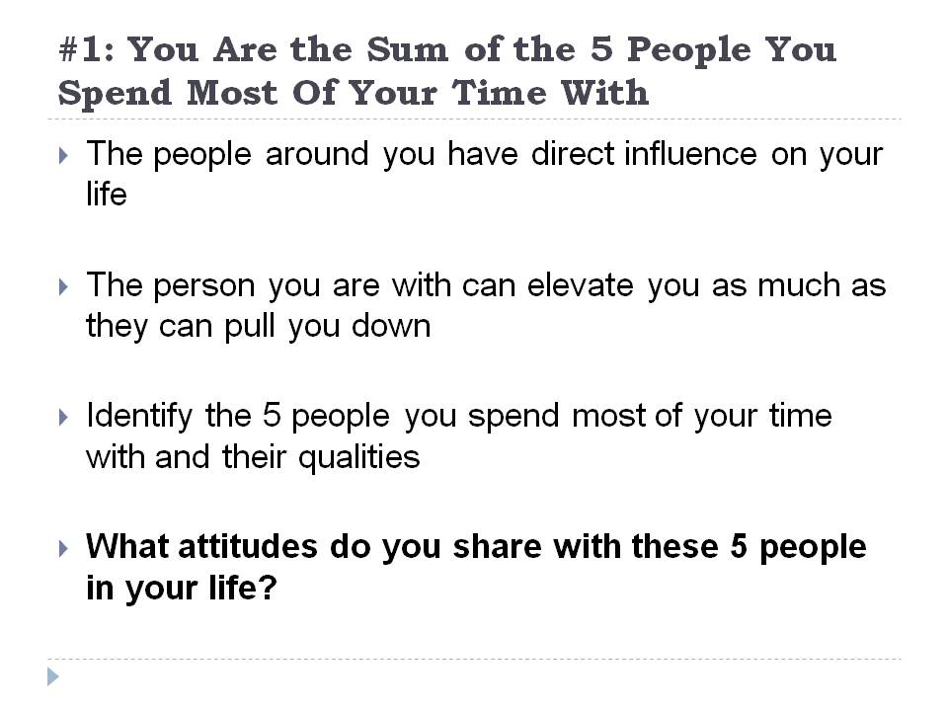

#1: You Are the Sum of the 5 People You Spend Most Of Your Time With

If you want to know your future, look at the lives of the people you are presently with. The people around you have direct influence on your life. You acquire some of their attitudes, principles and practices. You are like a small child that imbibes the practices of the adults around. When you go with dishonest people, eventually you alter your own values and acquire their dishonesty. However, if you go for honest people, their honesty reinforces your own personal values. The kinds of people you share your life with are very powerful personalities that affect your present actions and later own your future life. Because of their great impact in your life, it is very crucial that you know them very well. Once you know their influence on you, you will know how to take it to your own advantage.

The idea of being the sum of the people around you is often one of the most neglected parts of human psychology. Although this is not a novel thinking, people keep on ignoring the bearing of others in their lives. As a result, they just end up being like their detested character. This is all because they spent too much time with the person. The person you are with can elevate you as much as they can pull you down. The first step to change your future today is by knowing the five people from your core circle. In order for you to see their impact in your life, here are the steps that you can do.

Identify the Five people you spend most of your time with

Because you are the sum of the people around you, you need to be careful with the people you spend most of your time with. Although some of them are indispensable in your life, like your parents or siblings, try to spend as little time as possible to inevitable people with negative impact for your future life. Other people that you may frequently spend your time with are your friends, office mates or schoolmates and your special someone. Each person may have a different answer to the five people they spend most of their time with. But it will mostly revolve around these groups.

Identify the Qualities of these Five People

Once you have identified the five people in your life, try to assess each one’s personality. Look at them at every aspect of their life. Look at their family relationship, their dedication to work or school, their attitude towards problems and their outlook in life. Getting to know these people will help you know yourself better.

Identify the attitudes you share with these five people in your life

After knowing your core circle and their special attributes, try to assess your own life. What positive and negative characteristics do you possess? To whom can you relate your characteristics? When you are able to identify the major influence in that character trait, then you can do something about it. If you want to enhance a positive attribute coming from one of your core groups, then try to get closer to the person. The more time you spend with him/her, the better you can imitate that attitude. However, if you see mostly negative attributes to your core group, better reconsider your relationship with the person.

Every one needs a tribe. However, your tribe must exert a good influence in your life to benefit from it. If you are in the bad company, your future is at risk. Your choices today including your choice of company have a direct effect on your life. If you want to know your future, look at the lives of the people you spend most of your life with.

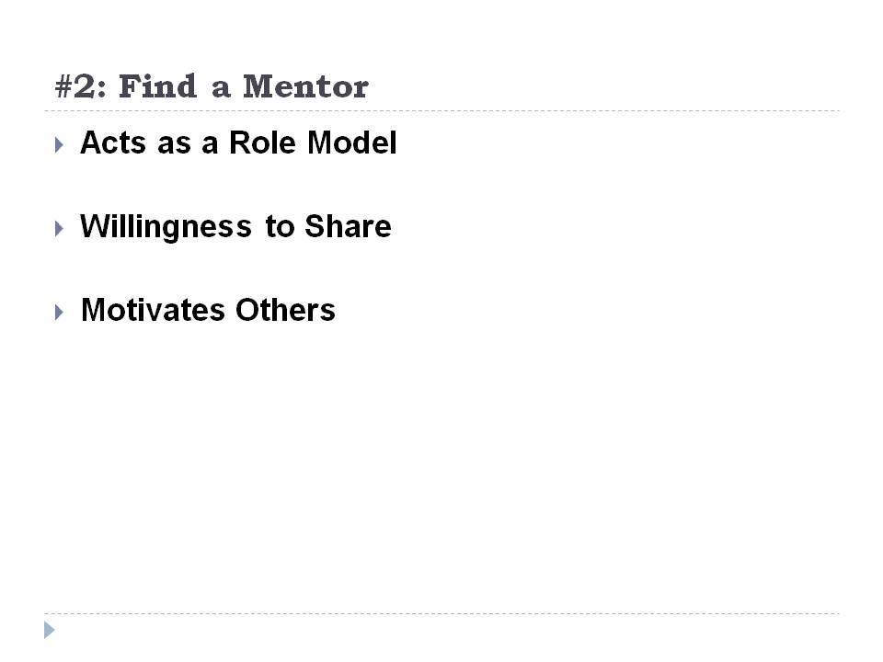

#2: Find a Mentor

Everyone look up to someone, it may be an old teacher, your parent or elder sister or brother or your very own best friend. The person you admire may serve as your mentor. Because you adore him/her, most likely you listen to his/her suggestions and teachings. A good mentor provides new knowledge, and directs you to the right path. If you wish to change your life tomorrow, look for a good mentor who will bring you to the kind of life you wish to have. To whether your mentor is good for keeping, here are the ideal characteristics of a mentor.

Acts as a Role Model

You have to practice what you teach. To be an effective mentor, you need to do what you say. The best way to direct a person in the right path is by modeling a good example. As the cliché goes, actions speak louder than words. If your mentor is worthy of emulation, look at his/her life. Otherwise, you must find other mentors to relate your life with.

Willingness to Share

A good mentor is someone who is willing to share the secrets of good life. If your mentor is open to share his/her expertise and teaches you the skills to succeed in life, you can trust the person with your life.

Motivates Others

A good mentor can bring out the intrinsic motivation in a person. For your mentor to be a good leader, he/she must bring out the best in you. Some students or followers go back to their old ways when the mentor disappears. If you are one of these people, your mentor is not effective. An effective mentor naturally brings out the inner motivation in his followers. Even in his absence, the followers stay within his teachings without the need for constant supervision.

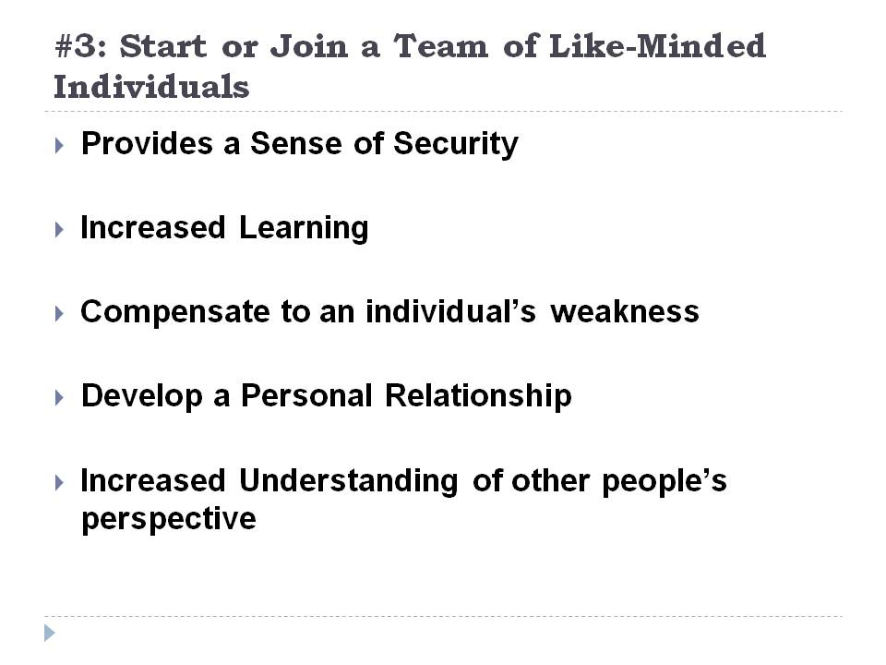

#3: Start or Join a Team of Like-Minded Individuals

A group’s effort is stronger than an individual’s effort. When you want to transform your life today, join groups or teams with the same interest as yours. Unlike when you are working alone to change some aspects of your life, a group effort is stronger and harder to disrupt. When you belong to a team, your conviction to better life is tougher and thus harder to break. When you reach a saturation point, your team can assist and support you along the journey. Contrary to working alone, the team with like-minded individuals can back you up when you lose your perseverance. Below are the advantages of working as a team.

Provides a Sense of Security

Working as a team gives you a feeling of security. When you have a group who shares the same interest as yours, you are sure of their support with any problem that may come. You know that there are people who stay with you and will guide you as you go along.

Increased Learning

As you work with people, you increase your knowledge with their experiences. Because you share common interest, you can draw wisdom from them. You do not have to experience personally things just to learn. By listening to their sentiments, you can learn a lot from the events in their lives.

Compensate to an individual’s weakness

Each person has his own weakness. When you work alone to change your future, even the small weakness can be deleterious to your goal. However, if you have a team, other members can compensate for your own weakness. They can assist you to deal with a weakness and teach you how to overcome it. You can draw strength from the team especially in your lowest situation.

Develop a Personal Relationship

Joining a team also provides you with relationships that are more personal. As you spend more time with your team, you can find friendship with them and influence each other. Again, in this case, we go back to the five people you spend most of your time with. Make sure that the team you will join will have a positive impact in your future life.

Increased Understanding of other people’s perspective

Because you are working with other people, you will have a better understanding on the way people think and act. You can use your learning to assess your own character and later on improve your self.

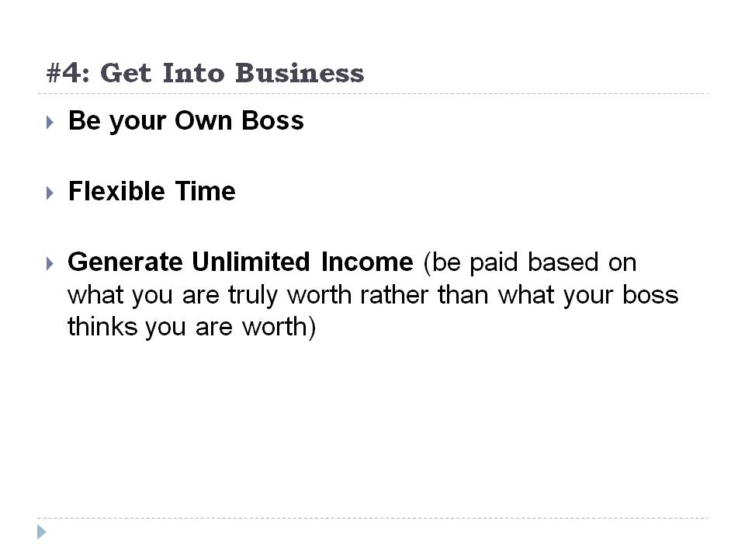

#4: Get Into Business

Most people who want to transform their lives start with a business. If you notice, the richest people are not employees but they are entrepreneurs who took the risk to do things on their own. If you want to achieve a better financial status in the future, you can begin establishing your own business today. Here are the perceived benefits of having your own business.

Be your Own Boss

If you are an employee, you need to get along with your boss and your coworkers. There are too many people to work with. You need to adapt to their personality and whims. When you have your own business, you become your own boss. You do not have to adapt to anyone’s caprice. All you need to do is work hard and work with your future clients.

Flexible Time

Working in an office means spending 8 hours in the area. You cannot leave the workplace since sanctions are ready for implementation. When you have your own business, you can own your time. You have the final say about your day off, working hours and your break time.

Generate Unlimited Income

Because you work on your own pace, you can generate more income as you wish. Unlike when you are an ordinary employee, you only receive your paychecks twice and at a predicted amount. In business, you can generate millions within days or years depending on your own capacity.



#5: Start a Bank Account for Investing Purpose

Starting a bank account helps you save your resources and invest for your purpose. Instead of keeping you money in your hands, having a bank account gives you countless of benefits. Here are the few advantages of maintaining a bank account.

Safer
When you have your bank account, you do not personally keep your money. The bank holds responsibility to your money. Therefore you safeguard it from thieves and possible disasters like natural and man-made calamities. Even during a bankruptcy, your money have insurance to keep the depositor’s worry free.

Easier to Save
Banks help you save money. Most people who overspend keep more cash with them. When you keep your money in the banks, you avoid too much spending. You also avoid withdrawing large amount of money in banks because of their existing withdrawal limits.

You Earn Interest
With bank accounts, your money works for you. If you keep your money in your own safekeeping, the value is the same from day one up to the day you will need it. If you keep it in banks, it becomes your personal investment because you earn interest every month.

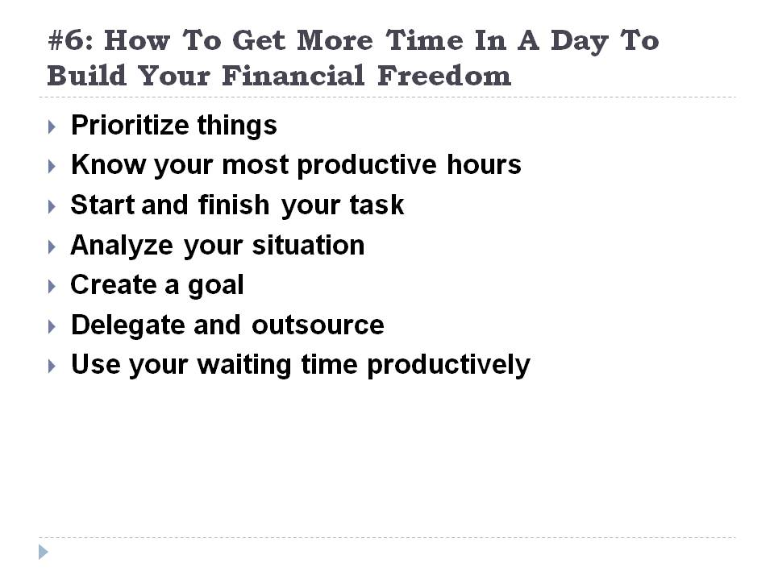

#6: Time Management: How To Get More Time In A Day To Build Your Financial Freedom

Sometimes you can hear people say that 24 hours in a day is not enough to finish all their work and meet all the deadlines. If you are one of these people, you will hear answers like “if you cannot find time, make time.” With the busy society that you are in, it feels that you need to compress everything in 24 hours. The secret to meeting your set goals is simply by ceasing to complain and sit down and start doing the work. Most people who keep on saying time is not enough are the people who love to complain. Instead of using the time working, they spend two or three hours complaining and discerning how to start the work. If others can compress all their obligations in the time given to them, why cannot you do it?

Time Management

The key to keeping up with your deadlines is through efficient time management. With the right allocation of your time and task, you can meet your target and still find time to relax. Although time management is a skill, you can learn it as you practice it. Here are some of the proven beneficial time management tips.

Prioritize things

You can start your day by listing the things you need to accomplish prioritizing those that are urgent. When you have a to-do-list, you can keep your mind focused on your list and prevent straying away from this. You can create the list by writing down those that need your immediate attention. Once you finish the most urgent one, you can start doing the next in line and so on. By prioritizing things, you prevent sacrificing a task over another.

Know your most productive hours

Different people have different levels of productivity during the day. Although most people are more productive in the morning, there are also people who find the restful afternoons to work at their best. If you are a morning person, try to delegate complicated task in the morning. When you know your most productive hours, you can allot this time to accomplish difficult work and set aside the easier ones during your idle moments.

Start and finish your task

The problem with people who complains of insufficient time is leaving a task unfinished and starting a new work. If you want to adapt a good time management skill, finish all tasks that you have started. Otherwise, your day will be over with several tasks open and hanging. In the end, you do not accomplish even a small work and you will totally screw up everything.

Analyze your situation

If you feel running after the clock each day, it is time to sit down and analyze the whole situation. There might be problems on the way you handle your time. Find out activities where you spend too much of your time. Once you discover these, then you can be more watchful when doing them. If you waste three to five hours surfing social network sites, you can reduce this to one hour to make the remaining hours more productive.
Create a goal
A goal is your motivation to time management. When you set your goals, be realistic. Remember that you only have 24 hours in a day. Never set goals that are not feasible. Otherwise, you will end up frustrated everyday.
Delegate and outsource
There is nothing wrong in volunteering your services to people. However, be realistic. You cannot be a hero everyday. Learn to delegate other task to trusted people and let them take responsibility for it. Much as you would want to do everything, multi-tasking is often difficult. If you are not good at it, you will end up sacrificing some things over another.
Use your waiting time productively
Waiting is one of the most time wasting activities. You wait for your turn in the cashier’s line, wait for the food service and wait for a long line in the department stores. You can spend these hours of waiting productively. Instead of watching the next leaf to fall or the next person who will enter the door, you can bring a good book to read or check papers or bring any handy task with you. As you learn to do this, the number of tasks you finish during your waiting times can save you from many obligations.
Time management is learning to use your time wisely and to your own advantage. It is a skill that no one teaches you but you need to learn to survive the challenges in life. For as long as you are keeping your things well organized, you are in control of your time and your life.
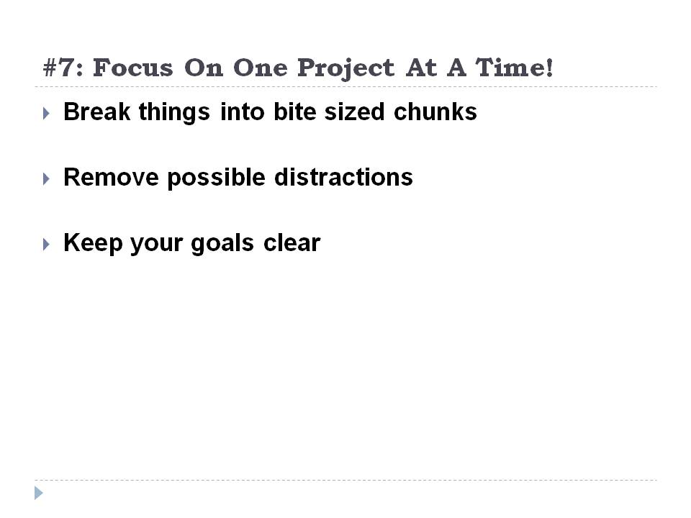

#7: Focus On One Project At A Time!

Our brains are like computers. When you put several tasks all at the same time, the computer hangs and breaks down. Like computers, our brain can only fully accommodate one project at a time. Although some people believe in multi-tasking, the quality of product produced from multi-tasking is not as efficient as the project produced with full focus. This is because your brain can only focus on a single thought at a time. When you follow the concept of one project at a time, your output is superior and is more likely to be completed.

Staying focus on one project and closing your thoughts from other tasks is quite difficult. The presence of constant distractions in the environment and in your mind can easily divert your attention to other things. No matter how difficult the skill is, you need to master it to create changes in your life that will be beneficial for your future. To help you learn the skill, here are the tips that you must follow.

Break things into bite sized chunks

Do not overwhelm yourself with huge task. If you can break it into smaller tasks, much better. Split difficult task in several smaller and attainable projects. Instead of getting an overpowering project, try to divide it into divisions.

Remove possible distractions

You work best in a quiet environment; find a quiet room where you can focus on your project. Avoid distractions like noise, interruptions and other forms of disturbances.

Keep your goals clear

One of the best ways to stay focused in a project is by making your goals clear. When you have clear goals, all will direct all your effort to attain the goal you set. It is easier to keep you motivated when you have realistic and attainable goals.

Conclusion

Changes do not occur in an instant. To create a longer lasting change for your future, you need to equip yourself with the necessary skills to ensure a successful future. Much as you would want to achieve your goals alone, this is quite difficult. The most successful people did not attain success on their own. There are people around that helped them be the person they wanted to be. IF you want to change your tomorrow, start acting today and look for people who will share the same sentiments that you have.

